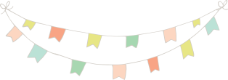  What does Daddy do at work? | If you could travel back in time, where would you go? | Why is wearing a seat belt in the car important? | What would you do if you saw a friend feeling sad?
What is your favorite thing to do outside? | What is your favorite snack? | What is your favorite season, and why? | What does Mommy do at work?
What would you do if you were invisible for a day? | My favorite song is: | I don’t like to eat: | Where is our family meeting place in case of fire?
If you could have any pet, which would you chose? | What would you do to make the world a better place? | How would you most enjoy spending your birthday? | When should you call 911?
What is the last dream you remember? | What makes someone a good friend? | What is your favorite subject in school? | What is the hardest work you have ever done?
What is your favorite dessert? | If you could have any superpower, what would it be? | What is your favorite part of the day? | Have you ever stuck up for someone being picked on?
What is something you did to help someone today? | What is the best part about our family? | What is your favorite color? | If you could have picked your own name, what would it be?
What’s your favorite animal? | I’m afraid of: | If you could cook for the family what would you make? | If you were granted three wishes from a genie what would you wish?

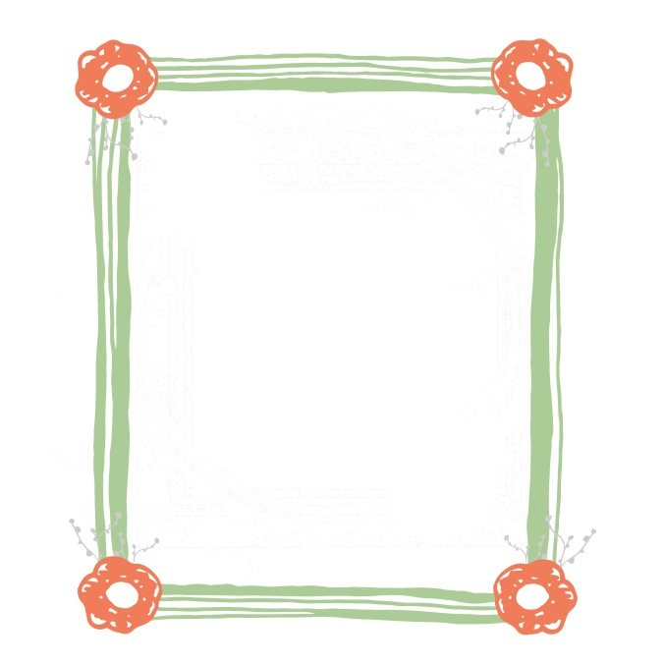
What are three things you like about yourself? | What is your favorite sport and why? | What is your favorite toy? | What is your favorite movie?
Name two things we should do as a family this weekend.

Dinner is a time to relax, laugh, tell stories and catch up on the day’s ups and downs. Oftentimes, eating dinner as a family is the best part of our day, as it is good for our spirit, brain and health. Use these fun ‘dinner table question cards’ to kick off great family conversations at your dinner table.
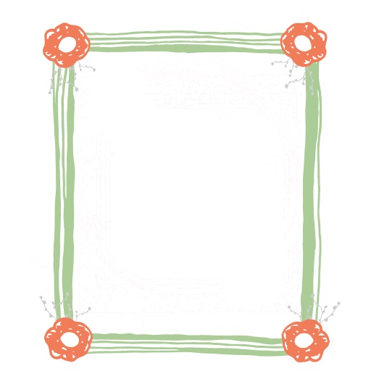
cards

dinner table question

